**DAILY ONLINE ACTIVITIES SUMMARY**

|  |  |  |  |  |  |  |  |
| --- | --- | --- | --- | --- | --- | --- | --- |
| **Date:** | **29/05/2020** | | | | **Name:** | **Tushit Shukla** | |
| **Sem & Sec** | **4 sem & B sec** | | | | **USN:** | **4AL18CS093** | |
| **Online Test Summary** | | | | | | | |
| **Subject** | | **OS IA Test** | | | | | |
| **Max. Marks** | | **30** | | **Score** | | **28** | |
| **Certification Course Summary** | | | | | | | |
| **Course** | 1. Java programing | | | | | | |
| **Certificate Provider** | | | **Great Learning** | **Duration** | | | **1s hr(spent by me on that day to learn)** |
| **Coding Challenges** | | | | | | | |
| **Problem Statement:**  Armstrong number is a number that is equal to the sum of cubes of its digits. For example 0, 1, 153, 370, 371 and 407 are the Armstrong numbers.  Example 1: Let's try to understand why 153 is an Armstrong number. 153 = (111)+(555)+(333) where: (111)=1 (555)=125 (333)=27 So: 1+125+27=153  Example 2: 371 = (333)+(777)+(111) where: (333)=27 (777)=343 (111)=1 So: 27+343+1=371 | | | | | | | |
| **Status: Completed** | | | | | | | |
| **Uploaded the report in Github** | | | | **Yes** | | | |
| **If yes Repository name** | | | | <https://github.com/tushitshukla29/lockdown-program> | | | |
| **Uploaded the report in slack** | | | | **Yes** | | | |

**Online Test Details**

OS TEST Details:

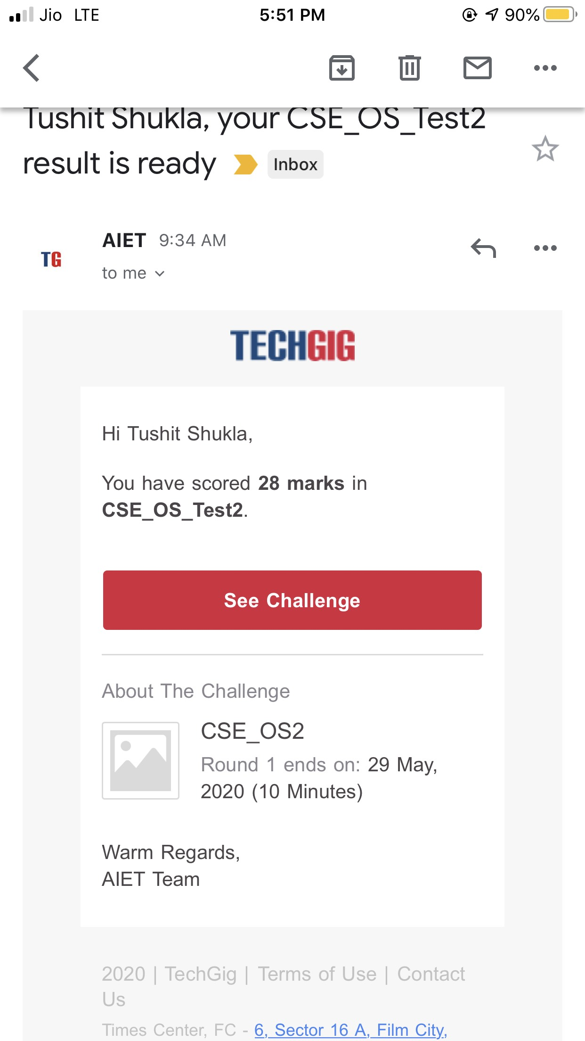

**Online Certification Details**:

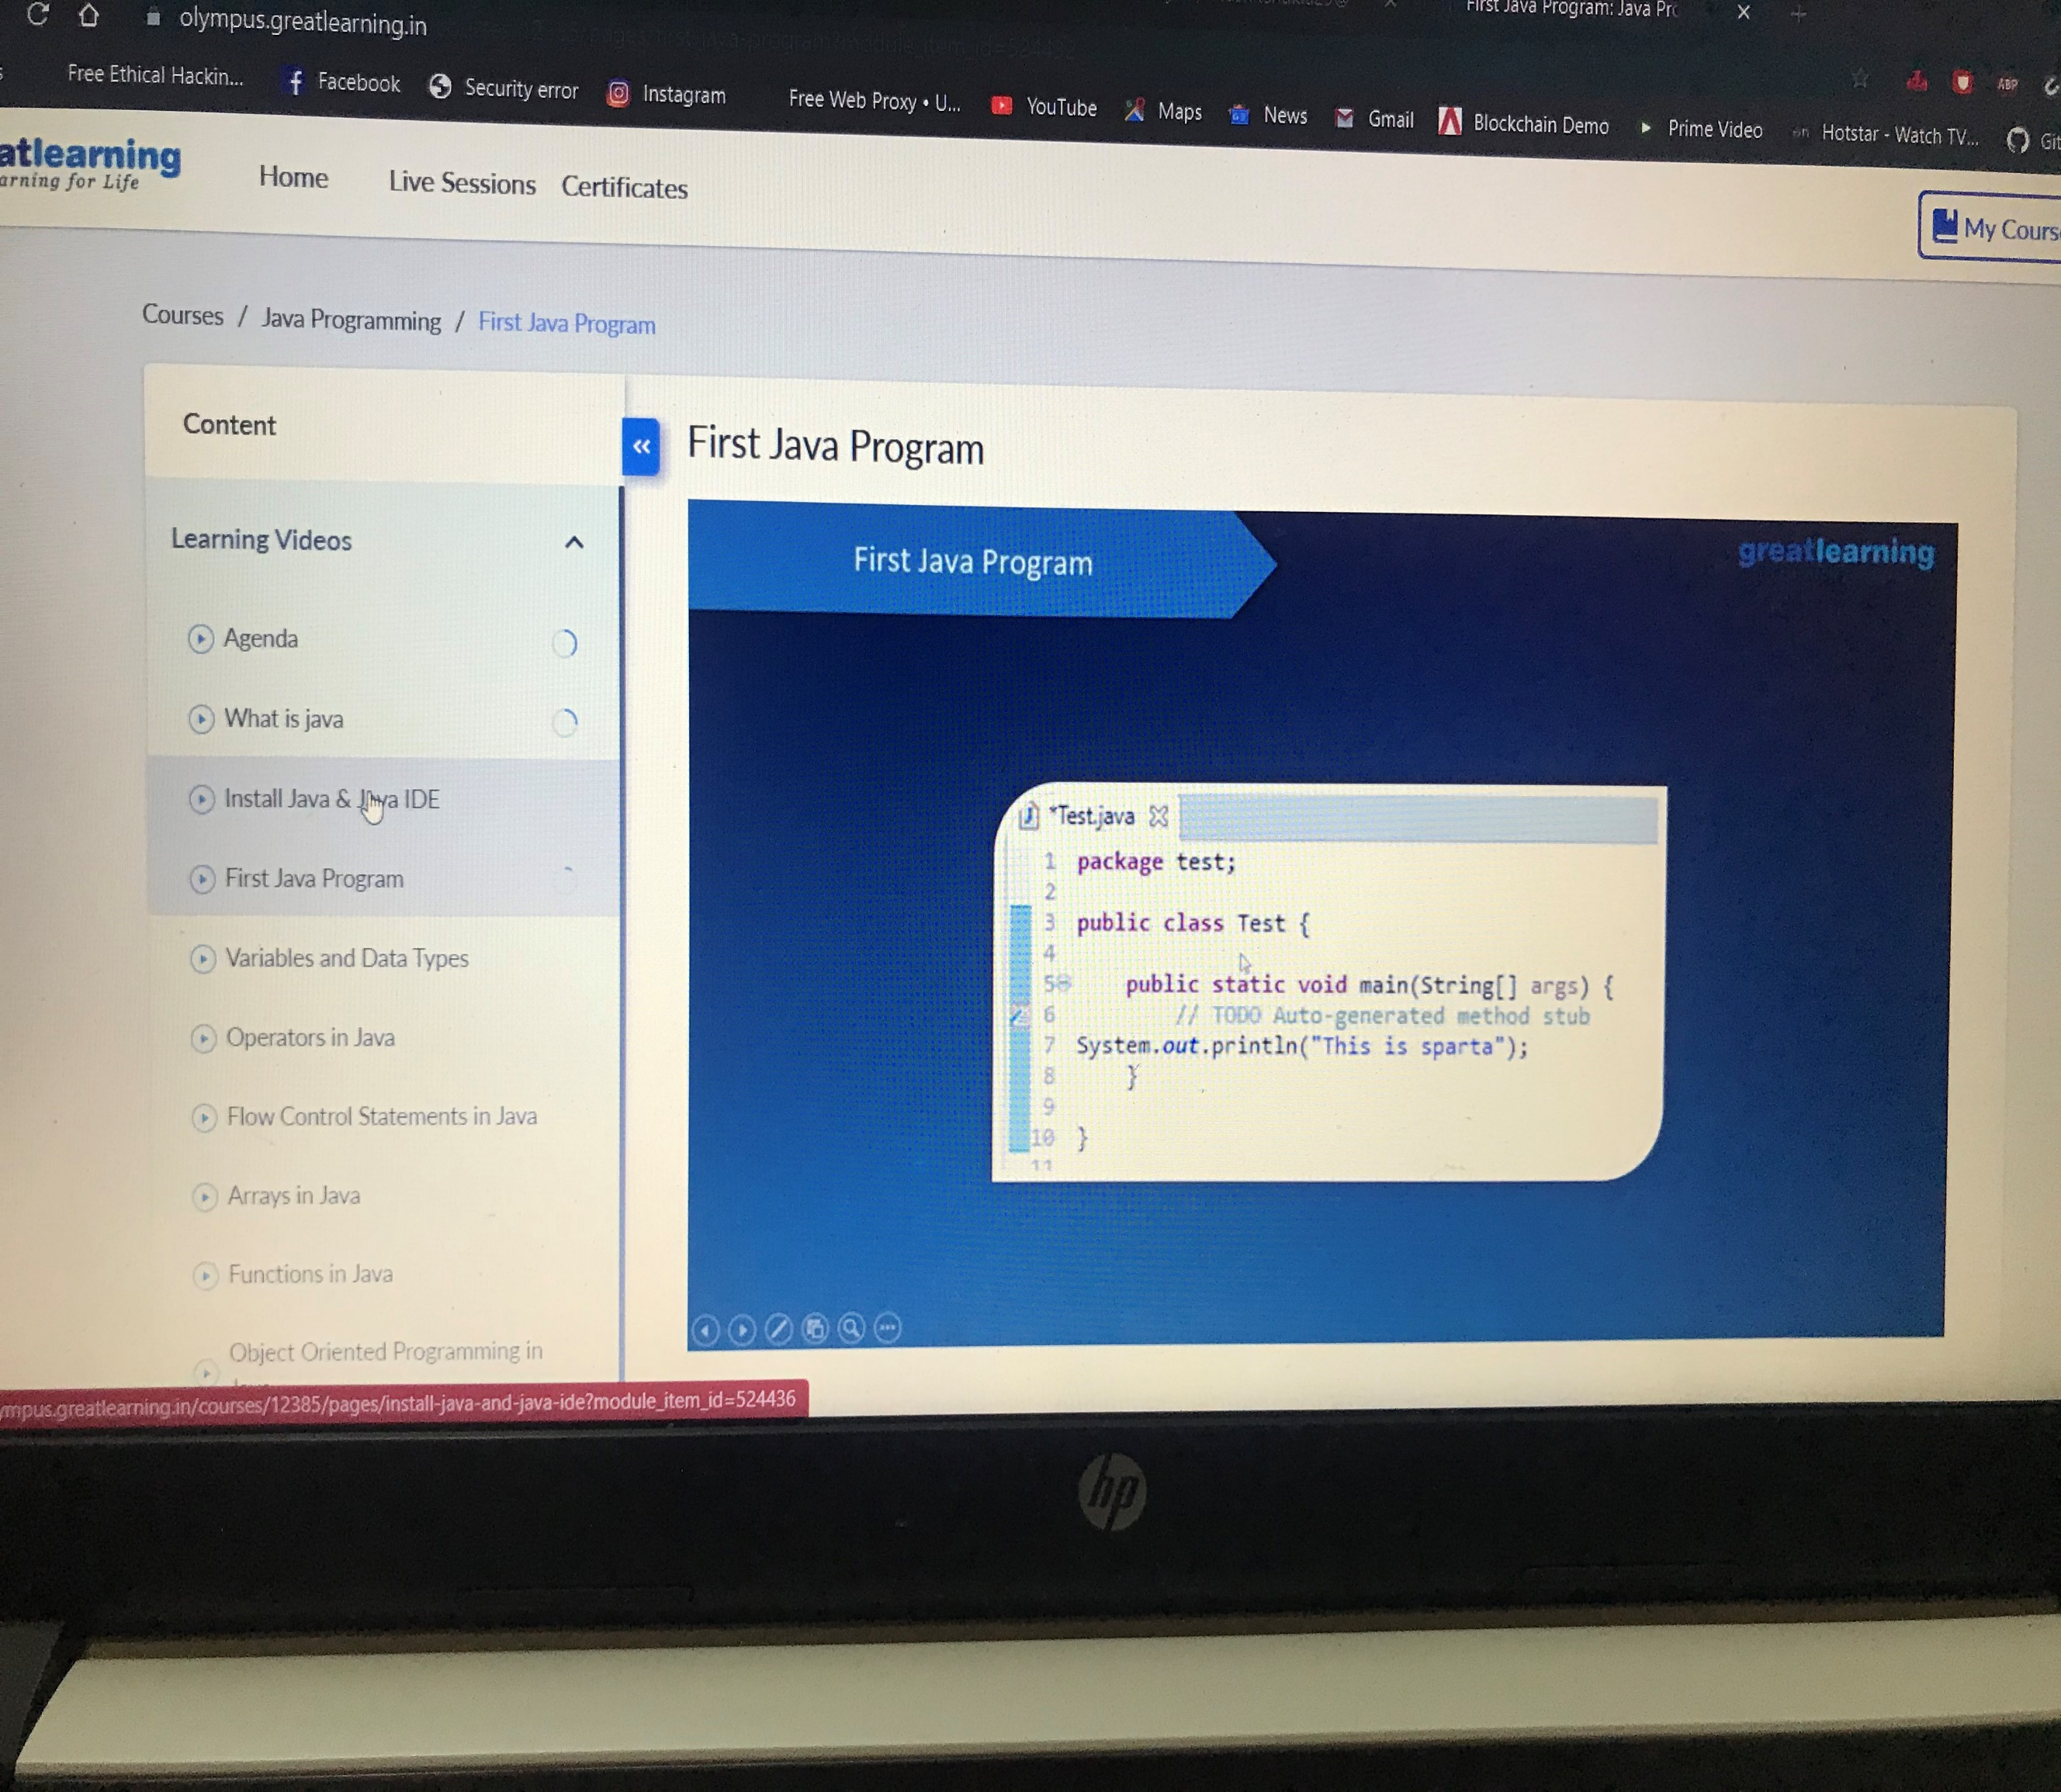

**Coding Challenge Detail :** I have written programs and uploaded it to my Github repository.

Link as follows: 1 <https://github.com/tushitshukla29/lockdown-program/blob/master/armstrong>